**Nama : Arief Nauvan Ramadha**

**Kelas : 4 Personal Branding 12**

* Halaman Linktree

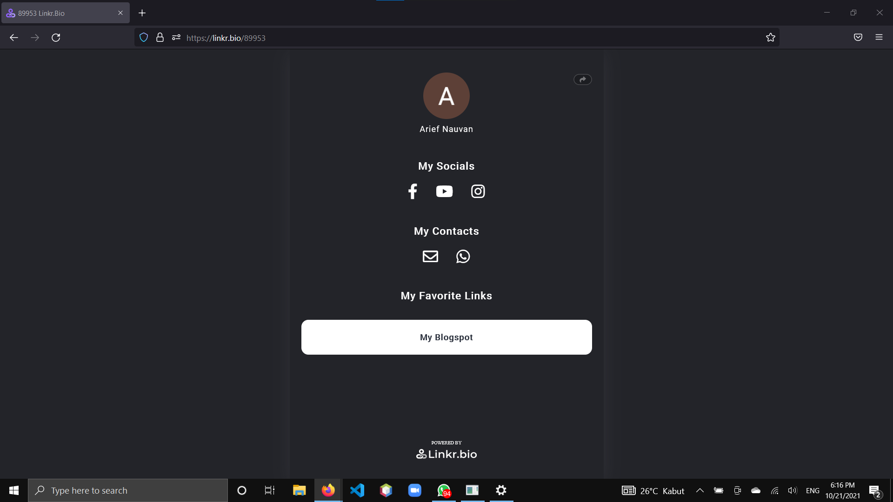

* Halaman Facebook

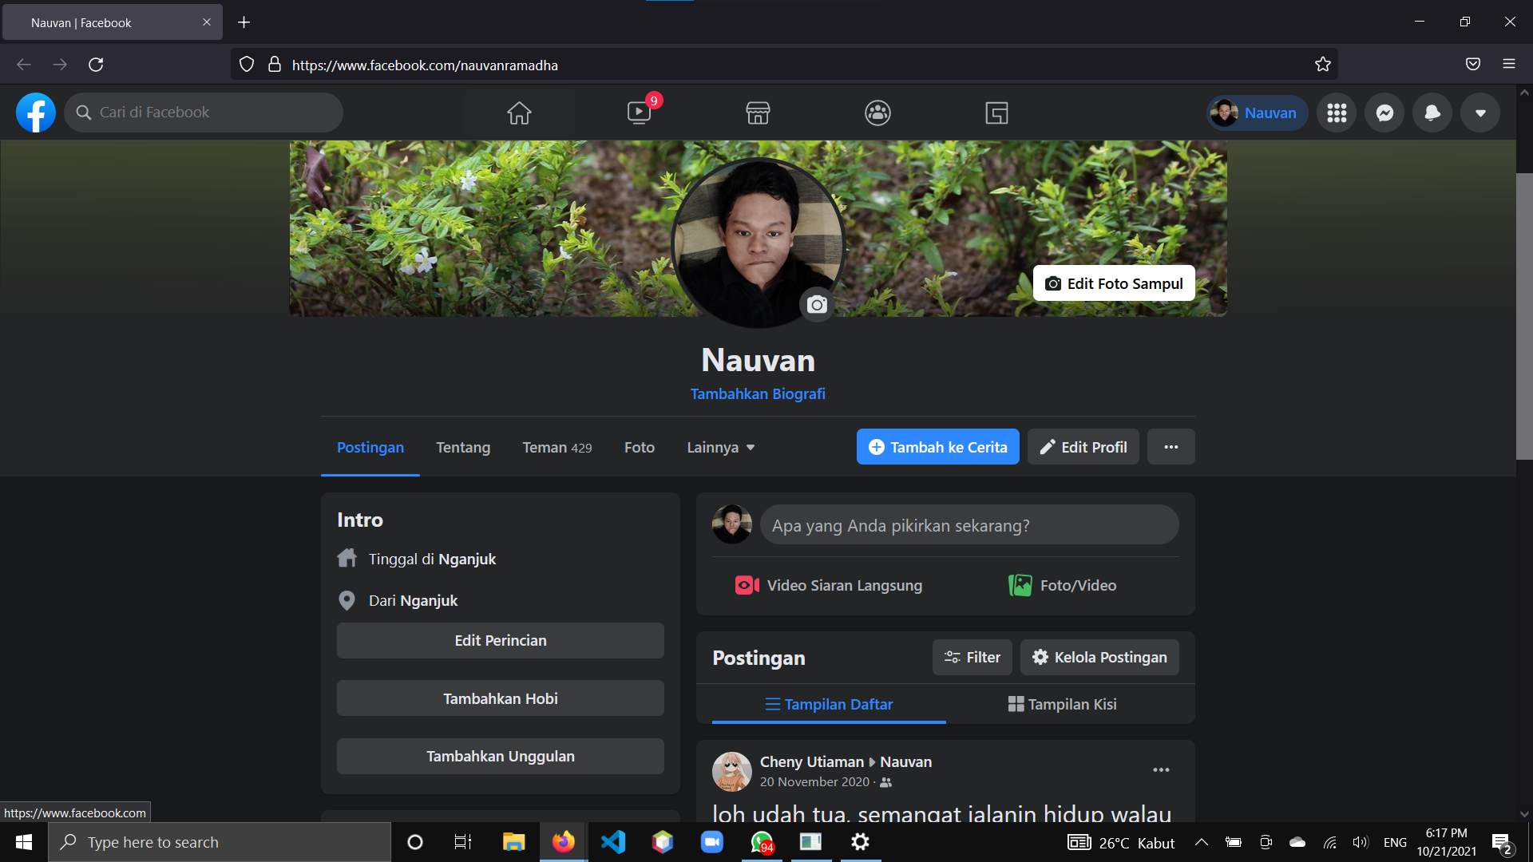

* Halaman Youtube

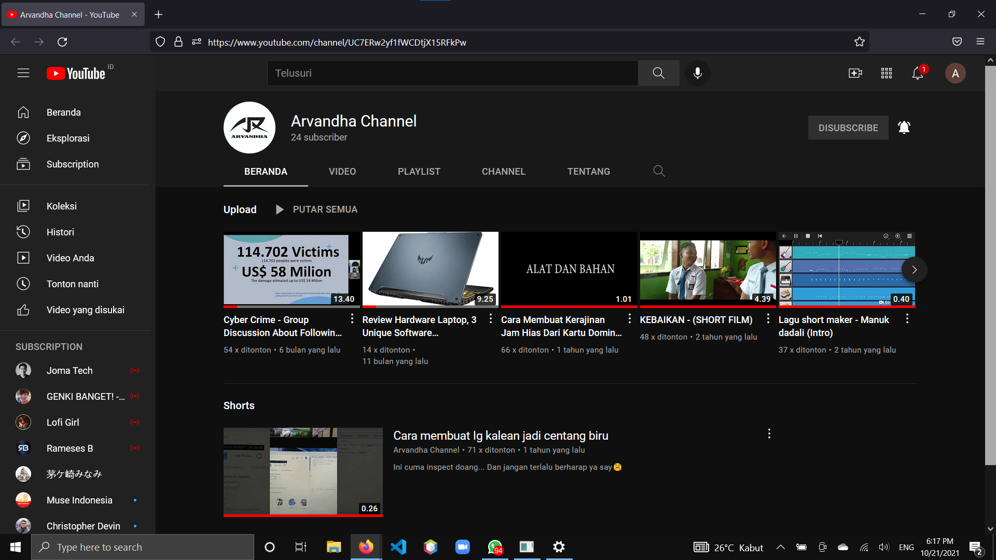

* Halaman Instagram

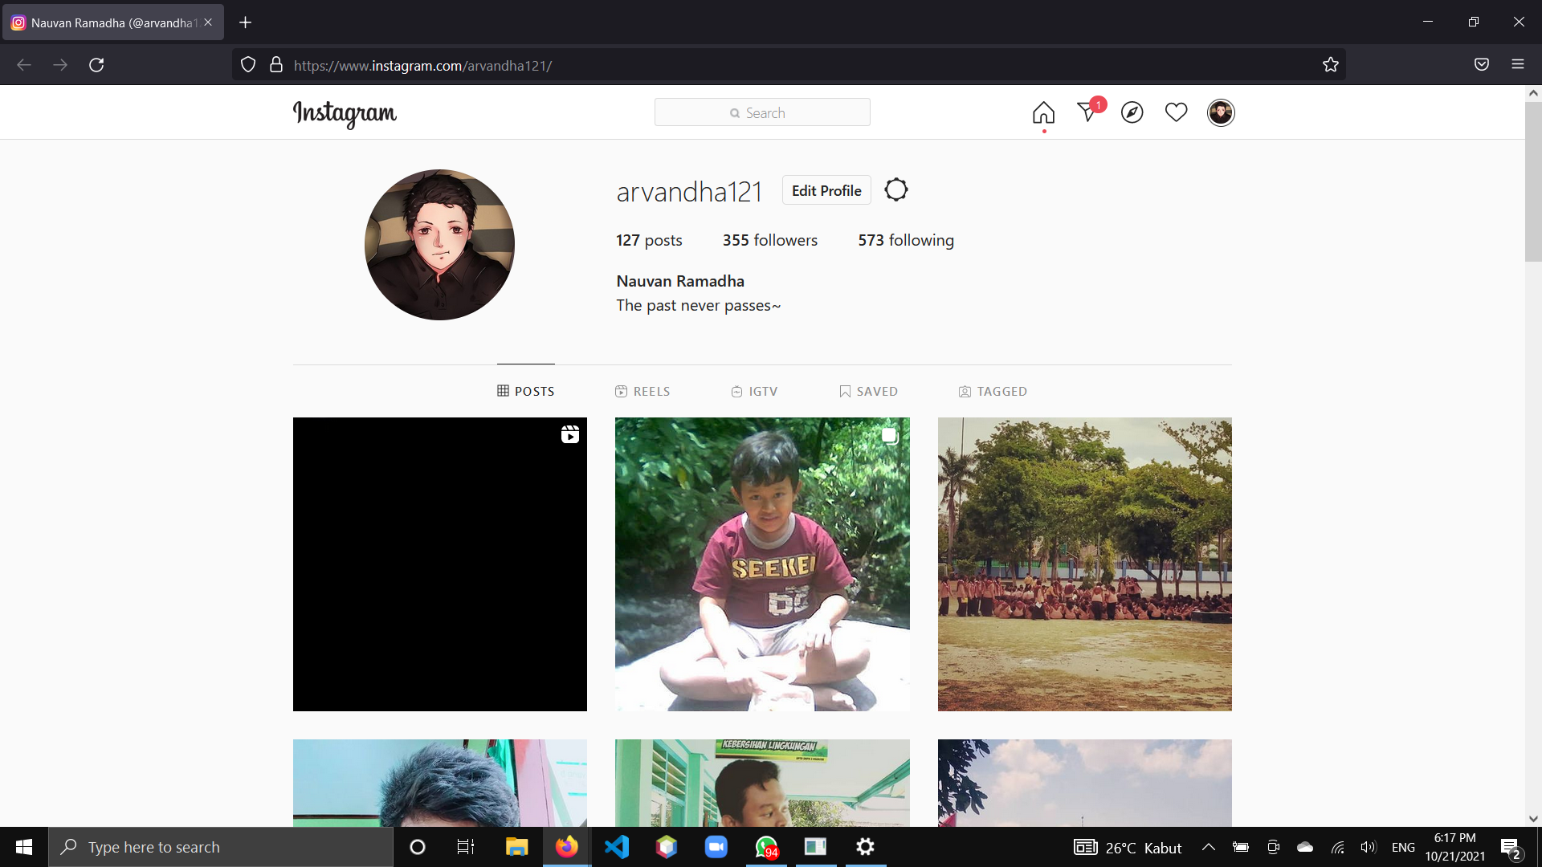

*Halaman Blogspot

